42.8: Each atom has a mass m and is at a distance 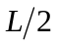 from the center, so the moment of inertia is

